**Project development documentation**

**1 Introduction**

The theme of this project is "Sport", which is a choice made by the people in the social background where the epidemic consumption is downgraded and the physical quality still needs to be improved.This document is intended to analyze and model and develop lightweight software for subsequent development.

**2 Brief Summary**

**2.1 Development background**

In recent years, the awareness of "the national fitness campaign" has gradually gained popularity. After the epidemic, people pay more and more attention to physical health, and are more willing to put their energy and financial resources into sports and fitness.

**2.2 Development objectives**

The purpose of this development is to develop a wide range of application, professional and recreational coexist sports software.Both office workers, elderly people or professional athletes can find information about their needs in this software.Can find the fun of sports in the entertainment, on this basis to provide professional guidance and teaching, can also understand the relevant event information, find sports venues to sport at anytime and anywhere.

**2.3 Design principles**

Lightweight design, the project to simple development.

At the same time, improve the universality

**3 Demand analysis**

**3.1 User characteristics**

|  |  |
| --- | --- |
| User classification | User characteristics |
| Management class | Relatively understanding of the software, have a certain professional knowledge |
| Ordinary people | Large age span and was interested in sports |
| Sports-related practitioners | More interested in the event |

**3.2 User stories**

3.2.1 As a user, I hope I can register successfully to log in the software and log out the information so that I can use it normally

3.2.2 As a user, I want to know the characteristics and precautions of sports, so that I can exercise correctly

3.2.3 As a user, I hope to watch instructional videos so that I can learn relevant skills

3.2.4 As a user, I hope I can see entertainment information about sports to kill time

3.2.5 As a user, I hope I can find venues sports quickly so that I can exercise in time

3.2.6 As a user, I hope I am able to choose the sports I like to avoid wasting time on screening

3.2.7 As a user, I want to be able to modify my personal information to stay fresh

3.2.8 As a user, I hope to be able to collect, like, and comment on information, so that I can have more sense of participation

3.2.9 As a user, I hope this software can allow me to get information about the latest competition and book the recent competition, so as to keep the situation of the event

3.2.10 As an administrator I want to be able to manage user information to facilitate regular maintenance of app runs

**3.3 Requirements summary**

According to the above user story analysis, the software functions include viewing sports information, features and precautions, recent sports venues and teaching videos; can search by keywords; able to edit personal information; can browse event information and book match; collect, like and comment, and administrators can add and delete user information.

At the same time, in order to meet the software goal as small as possible, the types of sports are limited to daily mass sports: running, rope skipping, aerobics, badminton, basketball, football, table tennis seven categories.

**3.4 Functional requirements**

**3.4.1 Brief description information:**

In the functional requirements, sports for a large category, including seven subcategories for specific sports, respectively [running, skipping, aerobics, badminton, basketball, football, table tennis] seven categories.To reduce the page setting, design a motion page containing seven ICONS to jump to the specific motion page, and then provide relevant functions.

In order to unify the style, the event module will also set up a home page, which contains two icons of [reservation results], and randomly displays the information related to the appointment and results.

**3.4.2 User function description**

1. User registration

|  |  |
| --- | --- |
| Function No.: | 001 |
| Function title: | User registration |
| functional description: | Provide the registration page, through the authorization verification, to give the operation permission |
| priority: | high |
| operation requirement: | Users are not registered and the network is in good condition |
| input: | User name, password, mobile phone number, verification code |
| flow path: | (1) Click on the registration page and jump to the registration page  (2) Enter the user name, password, confirmation password, mobile phone number, and check the protocol  (3) Click Send the verification code to match the verification code  (4) Please have registered successfully and return to the login page |

2. User login

|  |  |
| --- | --- |
| Function No.: | 002 |
| Function title: | users login |
| functional description: | Provide a login page to enable users to successfully log in to the App |
| priority: | tall |
| operation requirement: | User is registered, with a good network |
| import: | User name password |
| flow path: | (1) Enter the user name and password  (2) Click on Login  (3) Data incoming into the back-end alignment, successfully jump to the home page  (4) Failure prompts for the wrong user name / password |

3. Open the Motion home page

|  |  |
| --- | --- |
| Function No.: | 003 |
| Function title: | Go to the main page |
| functional description: | Provide sports home page (including seven specific motion icons, random information content) |
| priority: | centre |
| operation requirement: | The network is in good condition |
| import: | null |
| flow path: | (1) Enter the APP, try to load the main page, and send the request to the back end  (2) The back end accepts the request, and climbs the resource to return the data to the front end  (3) Success, the front end receives resources, rendering the motion home page  (4) Failure, then prompt "network fault, please refresh" |

4. Jump to the specific sports page

|  |  |
| --- | --- |
| Function No.: | 004 |
| Function title: | Open the specific motion page |
| functional description: | Provide a specific movement page (including three icons, information related to the specific movement) |
| priority: | centre |
| operation requirement: | The network is in good condition |
| import: | null |
| flow path: | (1) Click the corresponding icon in the sports main page page  (2) Page jump and try to load the page  (3) Send the request to the back end, climb the data and pass it to the front end  (4) The front end is successfully loaded and enders the specific motion page  (5) Failure, then prompt "network fault, please refresh" |

5. View the sports information

|  |  |
| --- | --- |
| Function No.: | 005 |
| Function title: | View motion information |
| functional description: | Provide information pages |
| priority: | centre |
| operation requirement: | Users have entered and the network is good |
| import: | Click on the information |
| flow path: | (1) Click on the information  (2) Jump to the information page and display the information details |

6. Check the sports characteristics and matters needing attention

|  |  |
| --- | --- |
| Function No.: | 006 |
| Function title: | Check the specific movement characteristics, matters needing attention |
| functional description: | Click on the relevant page to load the data |
| priority: | centre |
| operation requirement: | User has entered and the database is well connected |
| input: | null |
| flow path: | (1) Click the icon of movement characteristics and precautions  (2) Jump to the page, features,  (3) Send the request to the back end, the back end matches the motion id, and returns the data  (4) The front-end receives the data and successfully loads the page  (5) If you fail, prompt " the interface is wrong, refresh and try |

7. Venue information view

|  |  |
| --- | --- |
| Function No.: | 007 |
| Function title: | View venue information |
| functional description: | Provide information on sports venues and nearby venues |
| priority: | centre |
| operation requirement: | User has entered and the network is well connected |
| import: | Click the site icon |

8. Event appointment

|  |  |  |
| --- | --- | --- |
| Function No.: | | 008 |
| flow path: | (1) Click on the site icon  (2) Jump to the site page,  (3) Send the request to the back end, climb up the network information, and return to the front end  (4) The front-end receives the data and successfully loads the page  (5) Failed, prompt "network fault, refresh once" | |
| Function title: | | Check out the event and make an appointment |
| functional description: | | Provide event reservation information for reservation, and add reservation information to the database |
| priority: | | centre |
| operation requirement: | | Users are logged in, with good network connection and good database connection |
| import: | | Click to make an appointment |
| flow path: | | (1) Click the appointment icon and jump to the appointment page  (2) Click on the relevant events to display the detailed information  (3) Click to confirm the appointment and pass on the information to the back end  (4) Back-end alignment, stored in the database  (5) The front-end display that the appointment is successful  (6) Failed, display "appointment failed, try again" |

9. View of the event results

|  |  |
| --- | --- |
| Function No.: | 009 |
| Function title: | View venue information |
| functional description: | Provide information on sports venues and nearby venues |
| priority: | centre |
| operation requirement: | User has entered and the network is well connected |
| import: | Click the site icon |
| flow path: | (1) Click on the site icon  (2) Jump to the site page,  (3) Send the request to the back end, climb up the network information, and return to the front end  (4) The front-end receives the data and successfully loads the page |

10. Modify your personal information

|  |  |
| --- | --- |
| Function No.: | 010 |
| Function title: | Modify personal information |
| functional description: | Provide the modification page, and the user changes it |
| priority: | centre |
| operation requirement: | The user is logged in and the database is well connected |
| import: | Enter the information that you want to modify |
| flow path: | (1) Click on the Personal Center  (2) Select the information to be modified and make the modification  (3) Click Save to send the data to the back-end  (4) Back-end alignment, deposit in the database, return to the front end, successfully modification, (5) failure, display "failure" |

11. Search

|  |  |
| --- | --- |
| Function No.: | 011 |
| Function title: | search for information |
| functional description: | Enter the keywords to filter out the relevant information |
| priority: | centre |
| operation requirement: | The user has entered |
| import: | Enter keywords |
| flow path: | (1) Enter the keywords and click Search  (2) Send the request to the back end, the back end processing  (3) Return to the data, and use the front-end rendering interface |

12. Collect, like, comment on information and videos

|  |  |
| --- | --- |
| Function No.: | 012 |
| Function title: | Collect, like, comment on information / video |
| functional description: | Provide buttons / input boxes for favorites / likes / comments on the information / video page |
| priority: | centre |
| operation requirement: | The user is logged in and the database is well connected |
| import: | Click on button / enter the information |
| flow path: | (1) Click on the video / information  (2) Click thumb up / collect  (3) Click on the input box, edit, and click on send  (4) When clicking the button, send the data to the back end, compare with the back end, and deposit it in the database  (5) Page change (eg, like icon lit up) |

13. The administrator maintains the user information

|  |  |
| --- | --- |
| Function No.: | 012 |
| Function title: | Maintain user information |
| functional description: | Add, delete and check user information |
| priority: | tall |
| operation requirement: | The administrator is logged in and the database is in good condition |
| import: | Click / add / delete to check |
| flow path: | (1) Click the add, delete and change the check button to modify  (2) Transfer the incoming data to the back-end  (3) Back-end alignment, modification, and return to "successful modification"  (4) Failure, return to failure |

13.exit

|  |  |
| --- | --- |
| Function No.: | 013 |
| Function title: | Exit software |
| functional description: | Double-click Back twice, exit the software, and end the background run |
| priority: | tall |
| operation requirement: | Enter, and is running normally |
| import: | click the return icon |
| flow path: | (1) click the return twice to trigger the function and send the exit signal  (2) Exit the software and end the operation |

14. Logout

|  |  |
| --- | --- |
| Function No.: | 014 |
| Function title: | log-off message |
| functional description: | Remove the user data from the database |
| priority: | tall |
| operation requirement: | Login and running fine |
| import: | Click the Logout button |
| flow path: | (1) Click the Logout button, Send the request to the backend  (2) Back-end alignment removes data, returns, and successfully logs out  (3) Failure, return to failure |

**3.4.3 System functions**

Page jump, crawl resources, database connection

**3.5 Non-functional requirements**

**3.5.1. User interface requirements**

The simple page icon is clear

**3.5.2. Software environment requirements**

Need to use normally under ios

**3.5.3 Hardware environment requirements**

The phone has 50MB of space to work properly

**4 Overall design**

***(Clarer picture in the attachment)***

**4.1 Hierarchical block diagram**

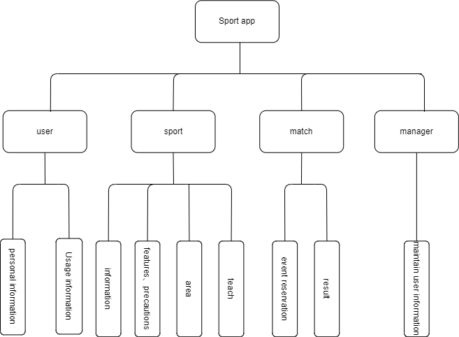

**4.2 e-r design**

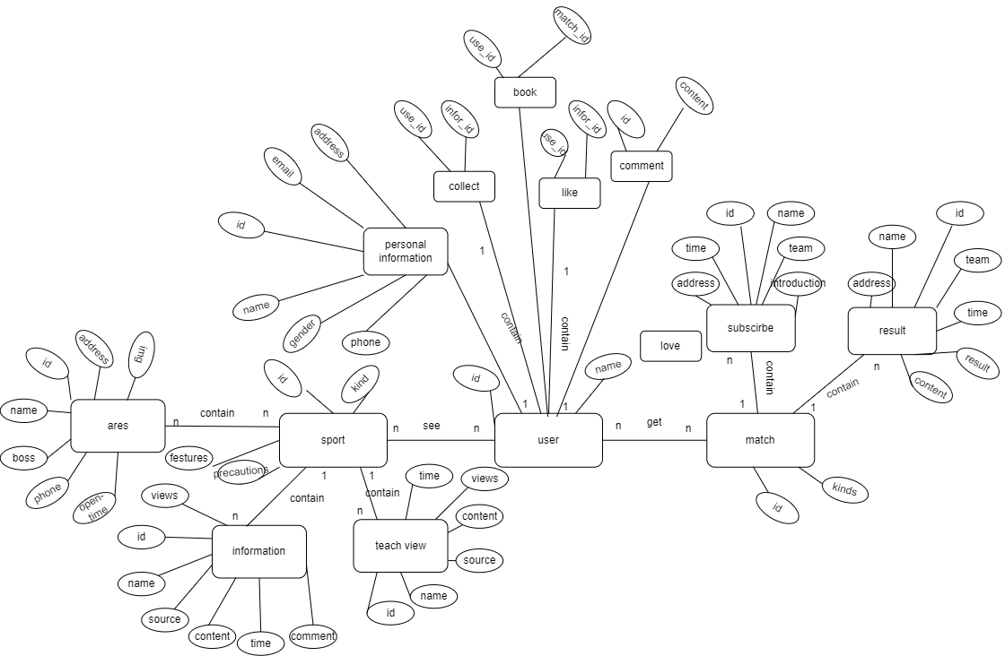

**5 Detailed design**

**5.1User case graph**

Total use case diagram:

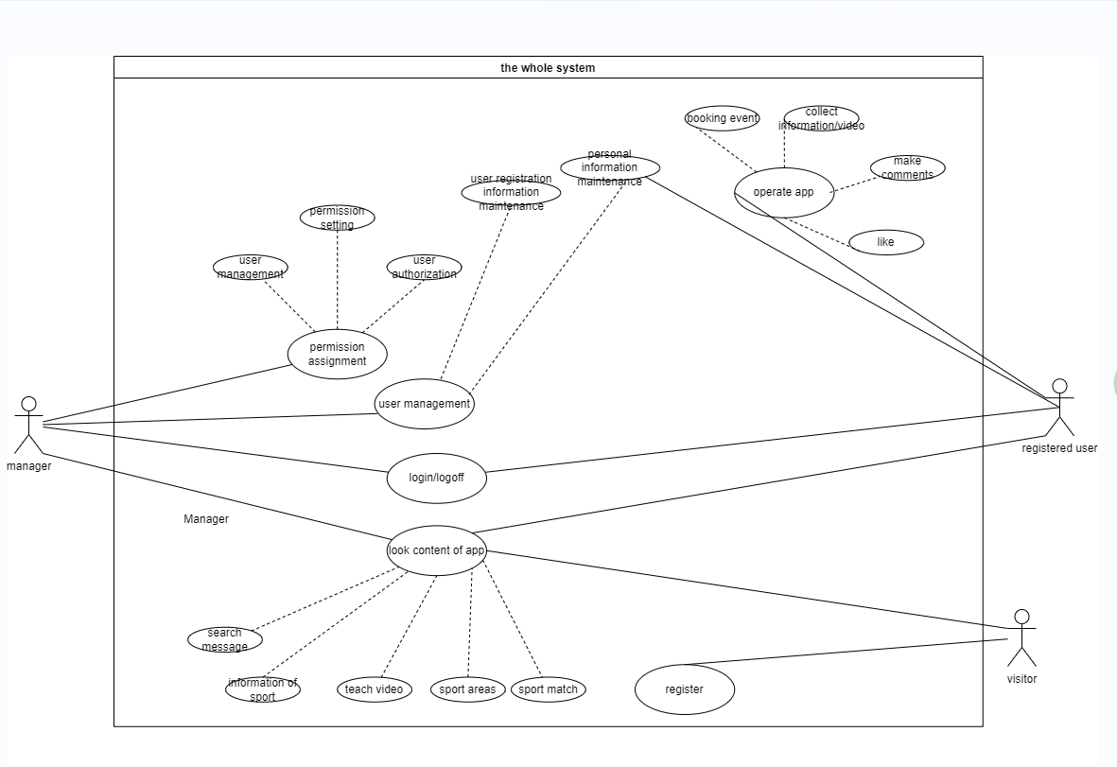

Sport module: User module:

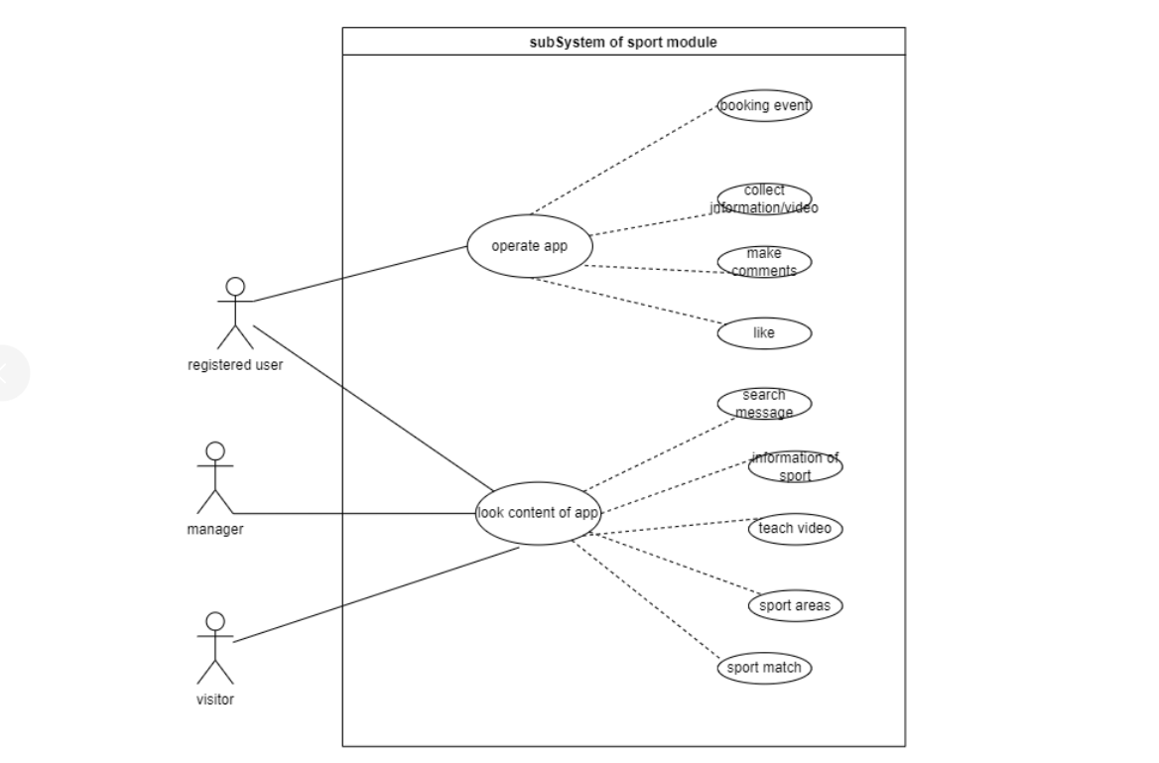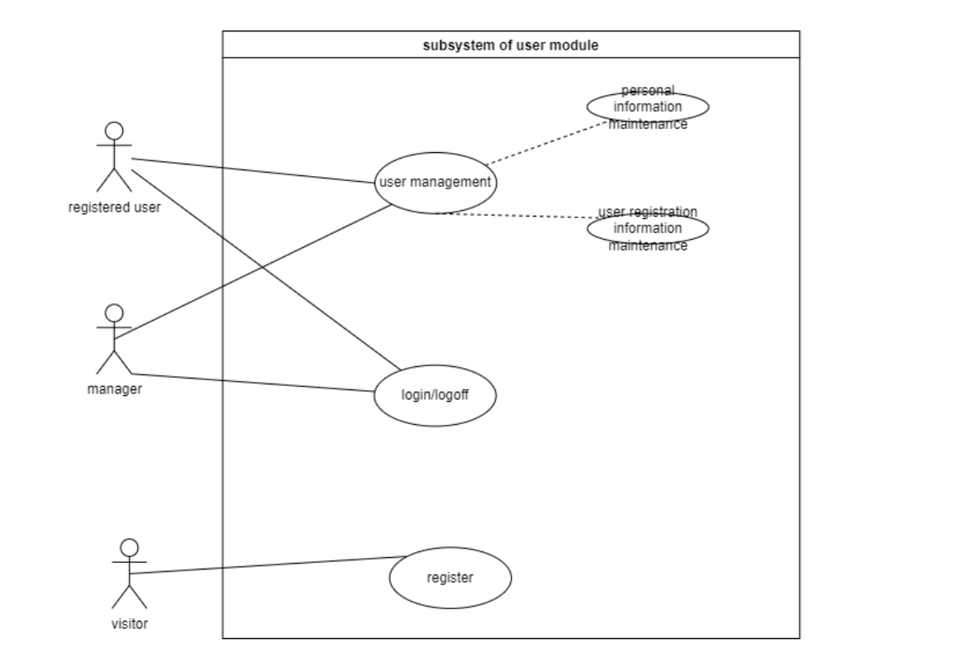

Match module:

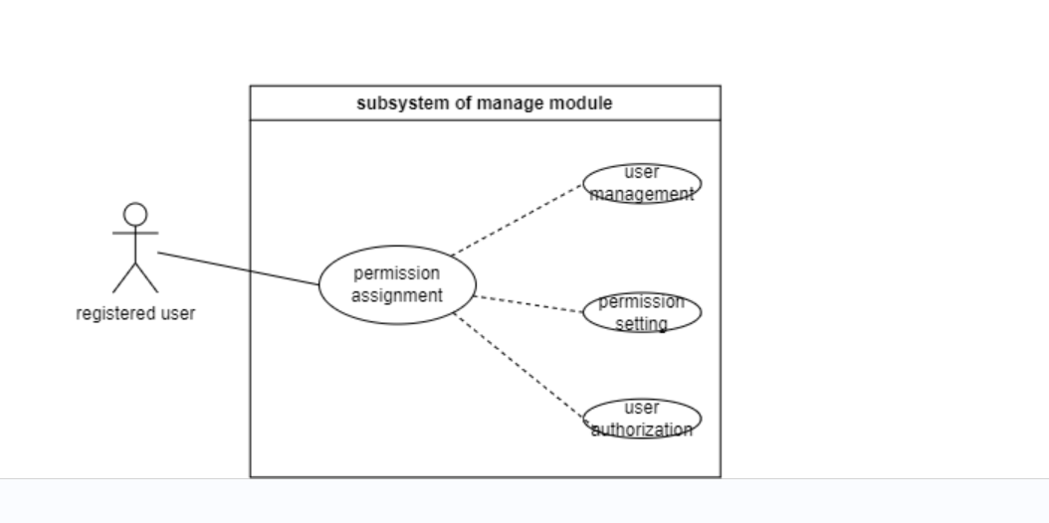

**5.2 sequence diagram**

**5.2.1. Login sequence diagram**

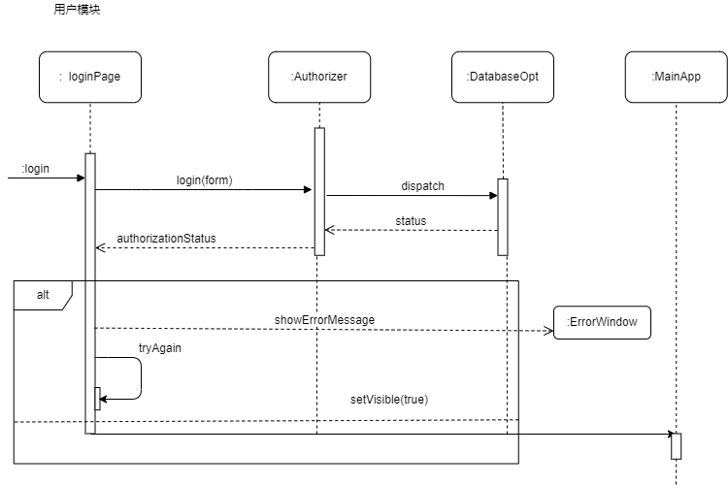

**5.2.2 sequence diagram of motion page module**

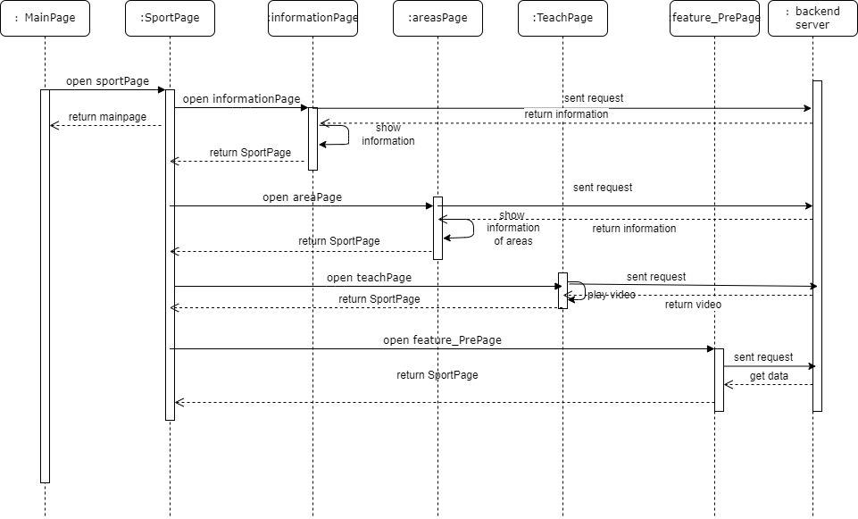

**5.3.3sequence diagram of event module**

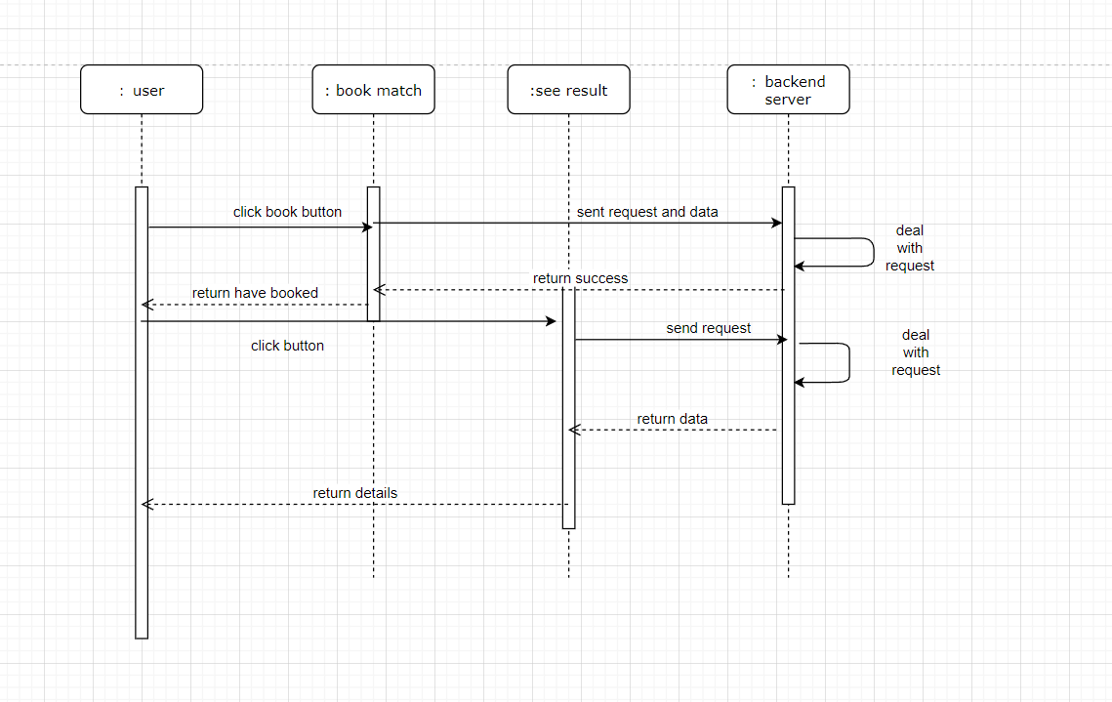

**5.3.4Some operational sequence diagram**

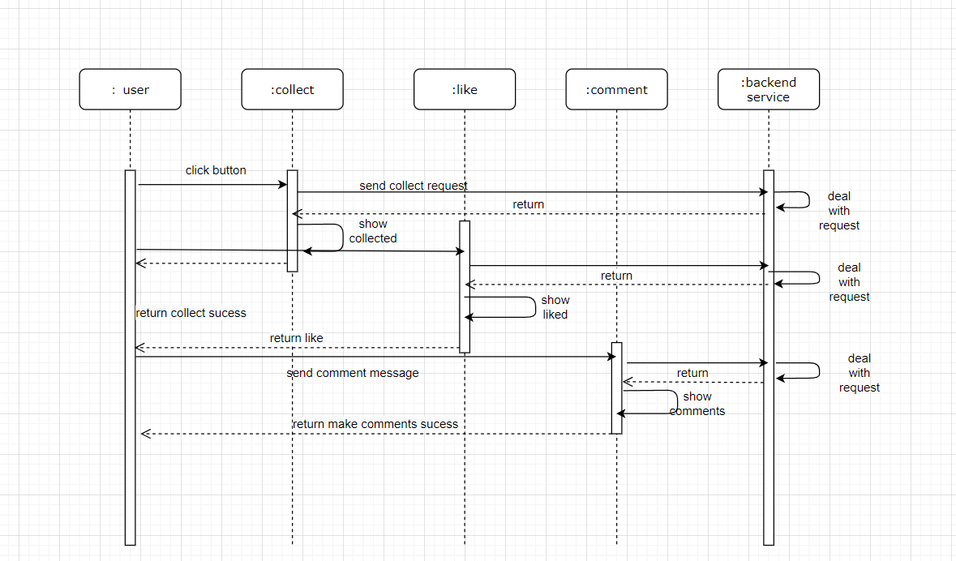

**5.3.5 Personal information sequence diagram**

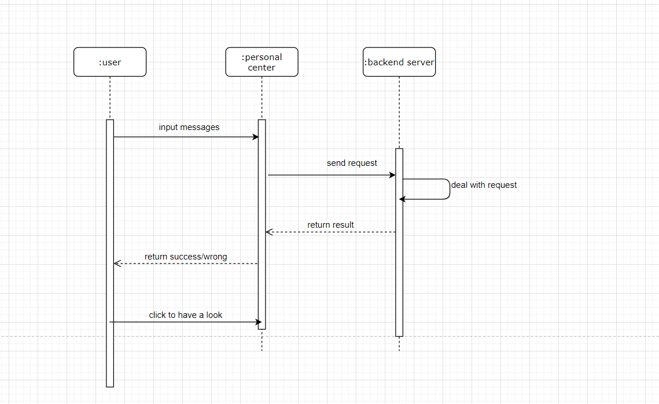

**5.4 Class diagram**

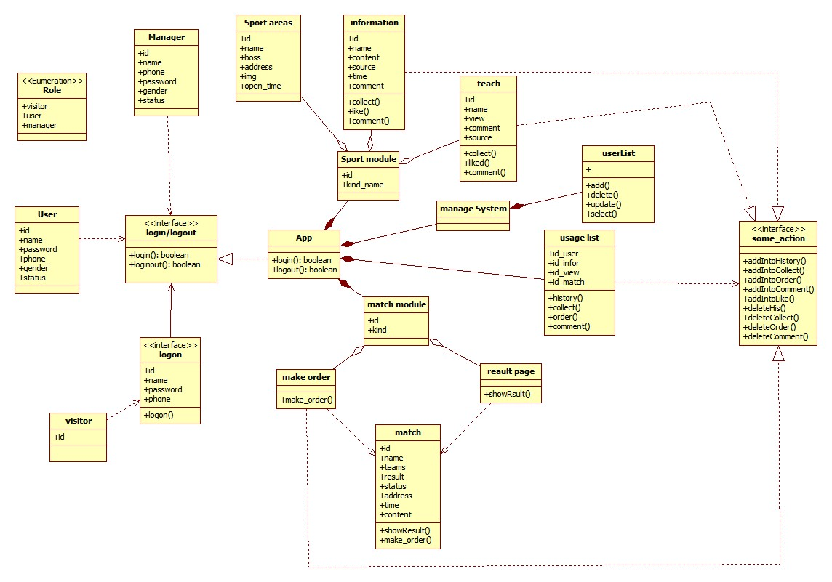

**5.5 architecture diagram**

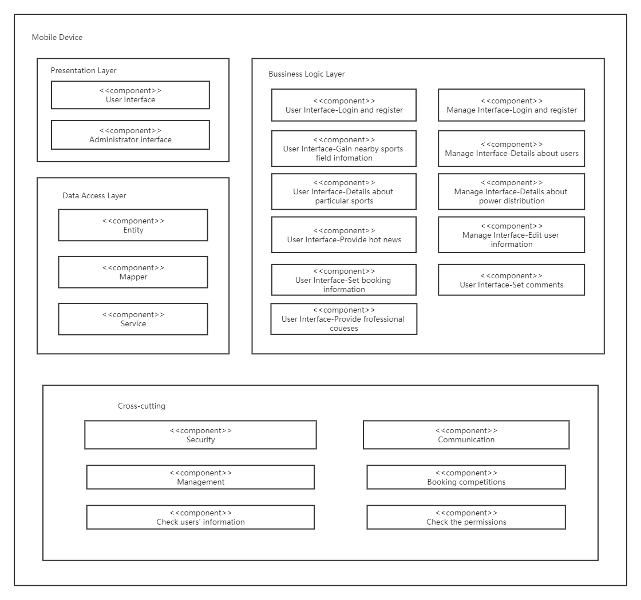

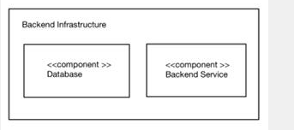

**5.6 ui page display**

***(This is only part of the ui desig.Please see the attachment for all the contents.We will submit it in the link to the submission code）***

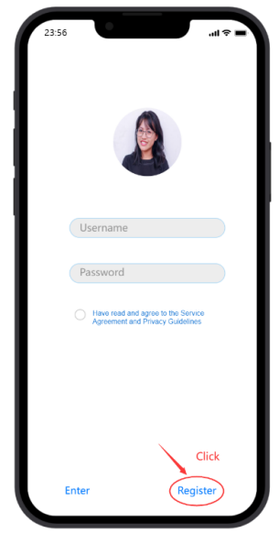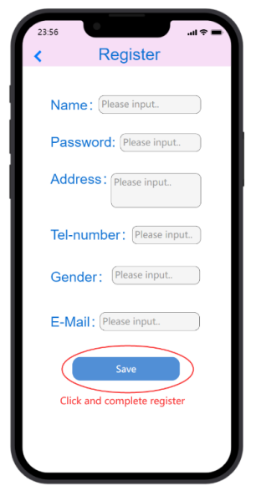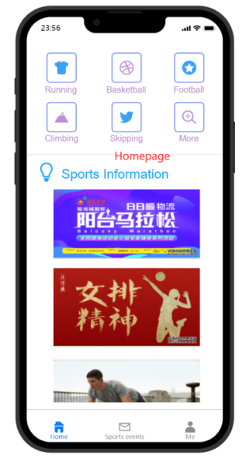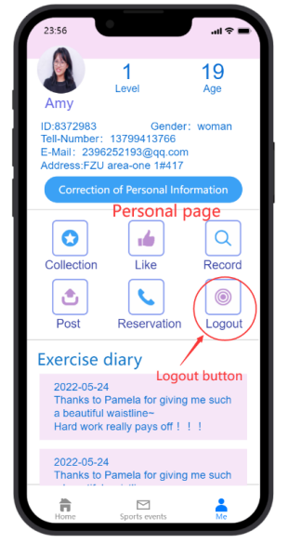

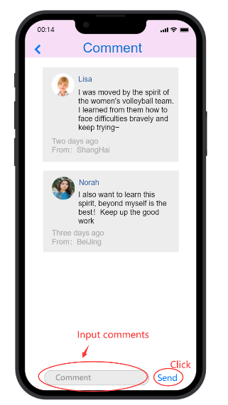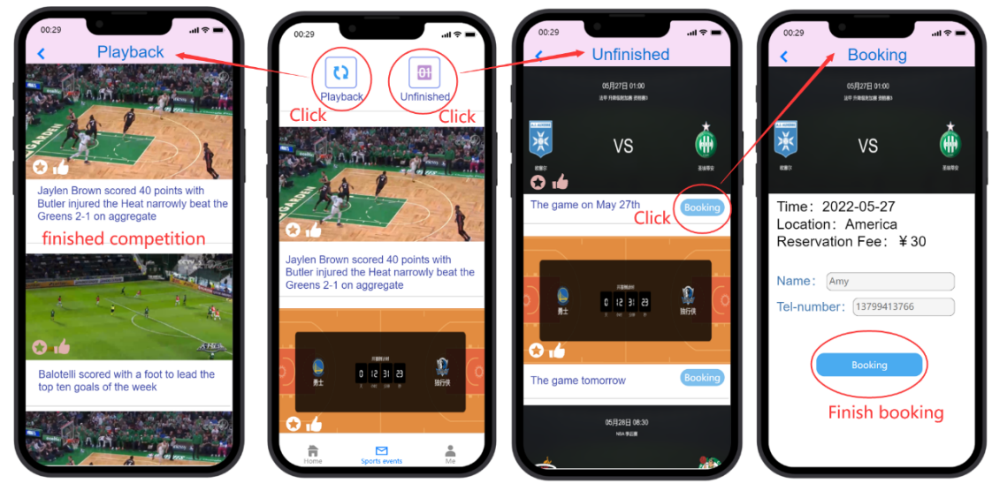

**6 Test outline**

**6.1 Purpose**

Provide guidelines for the management and technical work throughout the test stage while determining the scope of the test, provide the basis for the evaluation system, help to arrange the test activities, explain the demand for resources, and explain the evaluation indicators of the test results

**6.2 Main content**

Test the system to log in, and exit、Test system interface

Test conversion、Test data presentation

**6.3 Expected reader of this document**

Developers, Project Managers, testers

**6.4 Coverage of this test**

Log In / Exit Module Sports Module Event Module Individual Module

**6.5 Pass the test and achieve the following objectives**

Test whether the implemented project meets the design requirements

Specifically include: 1. Whether each function has been realized

2. Whether the process of each function is correct

3. Stable operation and operation specified by the product

4. The bug and the defect rate are within the controllable range

**6.6 Functional test**

Sports: view the information, features and precautions, teaching videos, and find the space

Event: Reservation check results

Personal: modify and view the personal information to delete and change the use of information

Administrator: Add, delete, and check

**6.7 Test case:**

1.

|  |  |
| --- | --- |
| Test Case Number: | Test-001 |
| test item: | entry |
| Test title: | Enter error data |
| Preset conditions: | The test environment successfully opens the interface |
| method: | Enter the incorrect user name / password |
| Result: | Login failed, prompted for the wrong username / password |

2.

|  |  |
| --- | --- |
| Test Case Number: | Test-002 |
| test item: | entry |
| Test title: | Enter the correct data |
| Preset conditions: | The test environment successfully opens the interface |
| method: | Enter the correct username and password |
| Result: | login successfully |

3.

|  |  |
| --- | --- |
| Test Case Number: | Test-003 |
| test item: | Keywords search |
| Test title: | Enter the keywords in the search box |
| Preset conditions: | Test environment successfully opens the interface, |
| method: | Enter the word "Badminton" |
| Result: | Return the badminton-related information |

4.

|  |  |
| --- | --- |
| Test Case Number: | Test-005 |
| test item: | Page jump |
| Test title: | Click on the icon to jump successfully |
| Preset conditions: | The test environment page was loaded successfully |
| method: | Click on the badminton icon |
| Result: | Jump over to the badminton page |

5.

|  |  |
| --- | --- |
| Test Case Number: | Test-004 |
| test item: | View information |
| Test title: | Click on the information to view |
| Preset conditions: | The test environment is well networked |
| method: | Click on the information |
| Result: | Jump the information details page |

6.

|  |  |
| --- | --- |
| Test Case Number: | Test-006 |
| test item: | Event appointment |
| Test title: | Make an appointment on the appointment page |
| Preset conditions: | The database is connected, and the test environment network is smooth |
| method: | Click the reservation button |
| Result: | A Successful Appointment is displayed |

7.

|  |  |
| --- | --- |
| Test Case Number: | Test-007 |
| test item: | Browse the features and precautions |
| Test title: | Open the page to render the information |
| Preset conditions: | The test environment is good |
| method: | Open the page |
| Result: | The page was loaded successfully, and the data was displayed normally on the page |

8.

|  |  |
| --- | --- |
| Test Case Number: | Test-008 |
| test item: | Watch the teaching video |
| Test title: | Teaching video can be played |
| Preset conditions: | Test environment network is good |
| Result: | Click the play button |
| Result: | The video was successfully played |

9.

|  |  |
| --- | --- |
| Test Case Number: | Test-009 |
| test item: | Edit personal information |
| Test title: | Modify information, database update |
| Preset conditions: | The database deposits data and can be read successfully |
| method: | Modify the username |
| Result: | Page, database user name was changed successfully |

10.

|  |  |
| --- | --- |
| Test Case Number: | Test-010 |
| test item: | Check out the sports field |
| Test title: | Open the sports ground page |
| Preset conditions: | Test environment network is good |
| method: | Click on the Playground button |
| Result: | The page was loaded successfully, to display the nearby site information |

12.

|  |  |
| --- | --- |
| Test Case Number: | Test-011 |
| test item: | user log off |
| Test title: | Log off personal information |
| Preset conditions: | The test environment database is well connected and saves information |
| method: | Click the Logout button to view the library information |
| Result: | Show a successful logout, exit the App, and the information in the library is deleted |

13.

|  |  |
| --- | --- |
| Test Case Number: | Test-012 |
| test item: | exit program |
| Test title: | Quit the end run |
| Preset conditions: | The test environment successfully opened the page and jumped successfully |
| method: | Double-click to return |
| Result: | Exit the program and end the run |

14.

|  |  |
| --- | --- |
| Test Case Number: | Test-013 |
| test item: | Maintain user information |
| Test title: | The administrator changes the user information |
| Preset conditions: | Predeposit data and library and read successfully |
| method: | The administrator click the edit button to disable the user account and try to log in with this account |
| Result: | Login has failed, and the display is disabled |

**6.10 Test criteria**

Quality criteria: error rate as low as possible, efficiency as high as possible, with reliability

Coverage quasi-test: high coverage of use cases

**6.11 End criteria**

With the error rate as the end standard, the error rate should meet a certain requirement

**epilogue:**

This is all of the project report. Thank you.